Weize Hong_ 24012988
Research Topic
How Cinematic Editing and Visual Storytelling in Game CG Trailers Construct Emotional Engagement？

Abstract: This paper argues that game CG trailers function as micro-narratives, designed not to convey complete stories but to construct emotional engagement and anticipation prior to gameplay. Through a close visual analysis of selected game CG trailers, this study examines how cinematic editing, alongside narrative rhythm, atmospheric lighting, and composition, shapes viewers’ emotional responses. The paper, based on the theories of cinematic language and micro-narrative storytelling, illustrates how editing contributes to the emotional development and condenses narrative meaning in a limited temporal frame. This research can help improve the comprehension of visual storytelling in the modern-day game industry and how emotional experience is pre-constructed before player interaction begins.

Key words: Micro-narrative; Game CG trailers; Cinematic editing; Visual storytelling; Emotional engagement; Game promotion

Contents Page:

- Introduction ……………………………………………………………….  - Literature Review ………………………………………………………..  - Game CG Trailers as Micro-Narratives …………………………………………………………...  - Editing and Narrative Rhythm ……………………………………………………..  - Conclusion …………………………………………………..  - Bibliography…………………………………………  - Image list………………………………………………………………. | 3  4  5  9  10  12  13

- Introduction
CG trailers and promotional videos are now among the key points of interaction between the games and the audiences in the present-day game culture.Long before players interact with gameplay systems, characters, or narratives, these short-form audiovisual texts shape how a game is emotionally perceived and anticipated.

Game CG trailers more and more take over cinematic styles similar to film trailers and short animation, as well as expressive editing, narrative rhythm, and atmospheric visual design. Even though they are short and not interactive, several of these trailers are very emotionally captivating, inviting the viewer to develop an affective bond with the worlds of fiction, the characters, and the experiences of playing the game in the future. This brings up an important question, how would game CG trailers build emotional involvement in such a limited and fragmented narrative form?

This paper examines game CG trailers as a form of micro-narrative that prioritises emotional orientation over narrative completion. The discussion also uses close visual study of the chosen CG trailers of the game as the specific subject of the discussion is the elements of editing and rhythm of narrative in building anticipation and emotional engagement. Comparing these approaches to those that are typically present in cinematic storytelling, the paper contextualizes game CG trailers as an intermediate audiovisual experience that sets up emotional feeling prior to the player's engagement in the world of the game.

- Literature Review
Scholars of film and media studies have long argued that emotional engagement in audiovisual texts is constructed through formal organisation rather than narrative completion alone. n terms of film editing, Murch (2001) also argues that emotional logic tends to dominate the editing process whereby the focus of decisions to be made should be on affective clarity rather than narrative continuity. When these concepts are applied to the short form and fragmentary media, Manovich (2001) and Ryan (2001) claim that sense of atmosphere, rhythm and situational elements can be used to create narrative engagement in the face of non-fully developed story structures. The combination of these views allows developing a theoretical framework of how game CG trailers, with all their shortness and fragmented plot, can form emotional involvement based on cinematic editing and visual narration.

Based on cinematic theories of emotional construction, scholars of game and interactive media studies have contributed more to the debate of emotional engagement beyond the moments of actual interaction. Calleja (2011) argues that player engagement is not limited to gameplay itself, but also includes anticipatory and affective orientations that form before interaction begins. In this respect, it is possible to influence emotional involvement by means of paratextual content, including promotional videos, that precondition the manner in which gamers experience a game world on an emotional level. Similarly, Jenkins (2004) suggested that games guide emotional and experiential engagement rather than delivering closed, linear stories. These views are specifically applicable to the consideration of game CG trailers, where the role of emotional engagement has been located as a planned action that comes before the interaction, rather than a by-product of interaction alone.

- Game CG Trailers as Micro-Narratives
Game CG trailers, instead of being mini-versions of full-fledged movie plots, should be more profitably defined as micro-narratives. Such trailers do not often pursue the explanation of characters, worlds, and events to the end. Rather, they give snippets - particular moments, visual images or moods of emotion - which direct the audience to some specific mood or emotional condition. There is a tendency to hide narrative information, the causality is not always clear, and conflicts are not resolved. Nevertheless, this seeming lack does not lessen interest. Instead, it prioritises emotional cues over narrative explanations, encouraging viewers to respond emotionally rather than cognitively. Although the plots may not be fully developed, as it is argued by Ryan (2001), narrative engagement may be created by the use of atmosphere and situational cues.

The boss fight against Malenia, Blade of Miquella (Figure 1) in Elden Ring provides evidence of the way in which cinematic editing and visual narrative can be utilized in games to build emotional, as opposed to narrative, exposition. Such sequence does not appear as a promotional CG trailer but as the part of an in-game and the cutscenes were incorporated into a personal gameplay. The first introduction of Malenia is characterized by an edited camera work: slow camera movement, controlled framing, and minimal musical emphasis establish a sense of solemnity and latent threat. The editing here serves temporal suspension, letting the player experience Malenia’s presence instead of instantly setting her as an antagonist that must be beaten. As Murch (2001) suggests, effective editing privileges emotional clarity over narrative logic, and this sequence exemplifies how editing functions as an affective reorientation tool. Elden Ring, in this way, shows how the application of cinematic editing to the gameplay goes beyond the spectacle itself and actively influences the involvement of the players by creating a sense of emotional build-up instead of narrative completion.

Another case is “Raiden Shogun: Judgment of Euthymia” (Figure 2) from Genshin Impact. The PV starts with the camera that pulled towards the city in a gradual movement starting at a distance to take the viewer into the environment, instead of introducing the main character as a whole.Then,the camera rises upwards as the sequence proceeds further and at the center of the architecture in the city, Raiden Shogun has finally come into sight. A distorted shot, a slow forward camera motion, and a short inverted shot increase the tension, after which the attention is paid to the character herself. The shots are finalized by one decisive attack with a sword, which is followed by the enormous sound effects, with the camera shifting to the dominant point of view on the scene. This orderly visual flow creates anticipation and emotional tension followed by a shift into other character centered sequences. Following this climactic moment, the PV transitions to a fast cut of demonstrations of gameplay abilities. The use of fluidity and control through smooth animation, rhythmic cutting and in sync with music makes the character appear to move with an emotional charge that is then turned into trust in the playable nature of the character. This spectacle/functionality shift shows how micro-narrative works in the various registers: first on the atmospheric anticipation, then on the symbolic impact and lastly, on the embodied action. Instead of answering narrative questions, the trailer prolongs the emotional action, inviting the audience to fantasize about further contact with the character. By doing so, cinematic editing and visual storytelling collaborate to convert the anticipation and admiration to affective contribution to strengthening the purposes of game CG trailers as means of emotional orientation as opposed to narrative fulfillment.

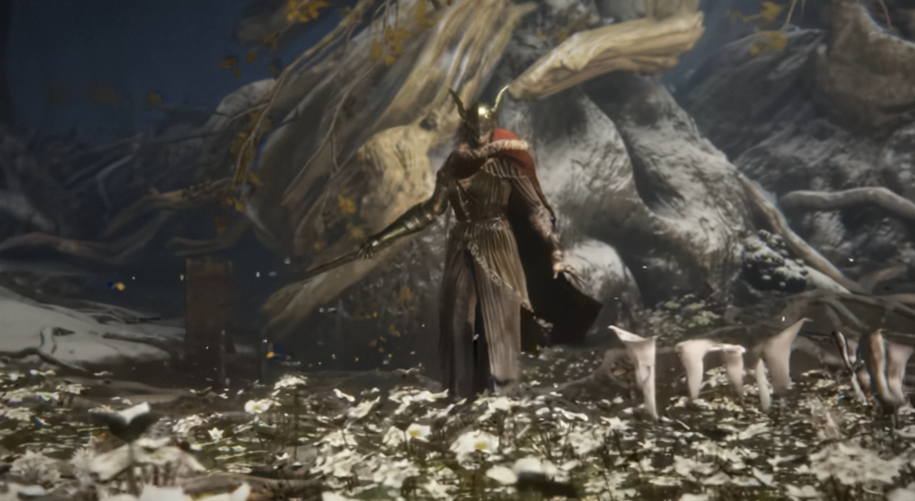

Fig. 1. Malenia, Blade of Miquella Boss Fight [Video]



Fig. 2. Raiden Shogun: Judgment of Euthymia [Video]

4. Editing and Narrative Rhythm
When applied to the game CG, the role of editing is not merely a technical operation of cutting pictures but it is the process of structuring time and rhythm to influence emotional involvement. Instead of leading the audience to the narrative resolution, the editing of game-related cinematics often forms the anticipation, tension, and affective orientation. In the case studies analysed above, narrative rhythm is created through the changes in pacing, duration of shots and switches between restraint and intensity. In the in-game cinematics, as well as in advertising PVs, a spell of visual build-up can be succeeded by moments of intense action or spectacle. These rhythmic changes do not answer narrative questions; they rather re-tune the emotional path of the viewer to set him/her in a high gears.

In contrast to the progressive approach of film editing towards closure, game CG editing is cyclical, holding the emotional impetus unsatisfactorily resolved. Through the influence of rhythm instead of narrative, cinematic editing emerges as a fundamental tool by which visual storytelling creates a sense of emotional involvement in which the anticipation of the player is placed in line with the experience of immersion instead of narrative satisfaction.

5. Conclusion
Rather than treating emotion as something that naturally emerges from story or character alone, the analysis suggests that emotional engagement is an experience actively shaped through editing. In the case studies before, emotion is not simply felt but constructed to be as the rhythm, pacing, visual focus and revelation moments are organised.

Both in-game cinematics and promotional trailers are discussed, which proves that the CG of games seldom is based upon full stories to attract players. Rather, emotional engagement is formed by the micro-narrative frameworks of how attention and expectation are oriented. Editing dictates when it is appropriate to conceal information, when it is appropriate to increase the attention of the visuals, and when it is appropriate to change the rhythm so that the anticipation and emotional suspense can build up the time.

By foregrounding rhythm and affect over narrative resolution, game CG adapts cinematic language to the specific demands of interactive media. Emotional engagement is constructed not to conclude an experience, but to prepare players for future interaction. From this perspective, cinematic editing, through its organisation of visual storytelling, functions as an emotional interface between player and game, shaping how players feel before they fully understand, and often before they even play.
\
Word count: 1657 words

Bibliography
Bordwell, D. (2016) Film Art: An Introduction. 11th edn. New York: McGraw-Hill Education.

Murch, W. (2001) In the Blink of an Eye: A Perspective on Film Editing. 2nd edn. Los Angeles: Silman-James Press.

Ryan, M.-L. (2001) Narrative as Virtual Reality: Immersion and Interactivity in Literature and Electronic Media. Baltimore: Johns Hopkins University Press. Available at: https://scispace.com/pdf/narrative-as-virtual-reality-immersion-and-interactivity-in-28p7rxrlrh.pdf (Accessed: 28 December 2025).

Manovich, L. (2001) The Language of New Media. Cambridge, MA: MIT Press. Available at: https://dss-edit.com/plu/Manovich-Lev_The_Language_of_the_New_Media.pdf (Accessed: 30 December 2025).

Calleja, G. (2011) In-Game: From Immersion to Incorporation. Cambridge, MA: MIT Press. Available at: https://doi.org/10.7551/mitpress/8429.001.0001 (Accessed: 30 December 2025).

Jenkins, H. (2004) ‘Game Design as Narrative Architecture’, in Wardrip-Fruin, N. and Harrigan, P. (eds.) First Person: New Media as Story, Performance, and Game. Cambridge, MA: MIT Press, pp. 118–130.

Image list
Elden Ring - Malenia, Blade of Miquella Boss Fight (2022). Available at: https://www.youtube.com/watch?v=D_iqjI2p7F4 (Accessed: 31 December 2025).

Genshin - Raiden Shogun: Judgment of Euthymia (2021). Available at: https://www.youtube.com/watch?v=mvrW4aKwAXw (Accessed: 31 December 2025).

